Assignment Description
Complete the following steps:
1) Implement a B-Tree Insert function within a program
2) Implement an AVL Tree Insert function within a program

1 Readme Documentation
My AVL tree implementation is fully functional. It correctly inserts values, maintains balance, and updates heights/rotations as expected.
The B-Tree insert function is partially implemented but not fully operational. The current issue appears to involve incorrect child indexing during insertion, which results in dereferencing a null child pointer. Due to the complexity of debugging the split/insert logic within the deadline, this version includes the implemented structure and methods but does not complete a fully working B-Tree insertion path.

2 Flowchart Screen Shots

3 UML and Use Case Diagrams
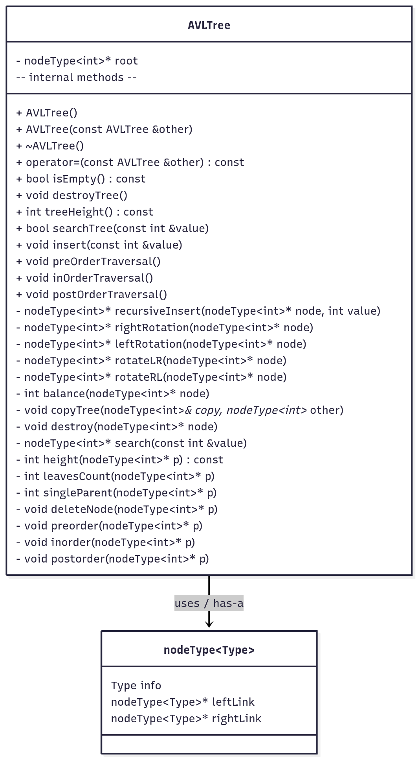

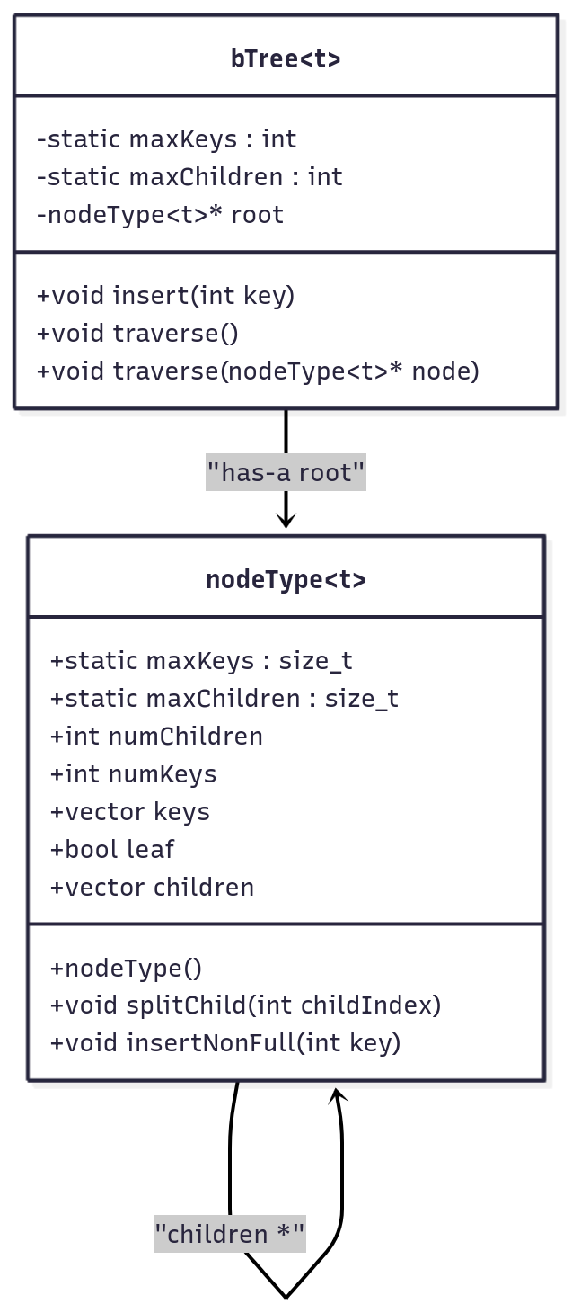

4 Source Code of All files (.h, .cpp)

B tree:

#include <iostream>
#include <vector>

/*
*Name: B-Tree insert
*Author: Wesley Hixon
*Date Last Updated: 12/4/2025
*Purpose: Demonstrate a B-Tree insert function
*/

template <size_t t>
struct nodeType{
static constexpr size_t maxKeys = 2 * t - 1;
static constexpr size_t maxChildren = 2 * t;

int numChildren = 0;
int numKeys = 0;
std::vector<int> keys;
bool leaf;
std::vector<nodeType<t>*> children;

nodeType(){
keys.resize(maxKeys);
children.resize(maxChildren, nullptr);
leaf = true;
}
void splitChild(int childIndex){
nodeType<t>* leftChild = children[childIndex];
nodeType<t>* newRight = new nodeType<t>;
newRight->leaf = leftChild->leaf;

leftChild->numKeys = t - 1;
newRight->numKeys = t - 1;

for(int i = 0; i < t - 1; i++){
newRight->keys[i] = leftChild->keys[i + t];
}
if(leftChild->leaf == false){
for(int i = 0; i < t; i++){
newRight->children[i] = leftChild->children[i+t];
}
leftChild->numChildren = t;
newRight->numChildren = t;
}

for(int i = numChildren - 1; i > childIndex; i--){
children[i + 1] = children[i];
}

children[childIndex + 1] = newRight;

int keyIndex = childIndex;

for(int i = numKeys - 1; i > keyIndex; i--){
keys[i] = keys[i - 1];
}

keys[keyIndex] = leftChild->keys[t - 1];

numChildren++;
numKeys++;
}

void insertNonFull(int key){

int insertionIndex = numKeys;

for(int i = 0; i < numKeys; i++){
if(keys[i] > key){
insertionIndex = i;
break;
}
}

if(leaf){
for(int i = numKeys - 1; i > insertionIndex; i--){
keys[i] = keys[i - 1];
}
keys[insertionIndex] = key;
numKeys++;
}
else{
int childIndex = insertionIndex;
if(children[childIndex]->numKeys == children[childIndex]->maxKeys){
splitChild(childIndex);
}

if(keys[childIndex] > key) childIndex++;
children[childIndex]->insertNonFull(key);
}
}
};

template <size_t t>
class bTree{
private:
static constexpr int maxKeys = 2* t - 1;
static constexpr int maxChildren = 2* t;

nodeType<t>* root = nullptr;

public:
void insert(int key){
if(root == nullptr){
root = new nodeType<t>();
root->leaf = true;
root->insertNonFull(key);
return;
}

if(root->numKeys == root->maxKeys){
nodeType<t>* newRoot = new nodeType<t>();
newRoot->leaf = false;
newRoot->children[0] = root;
newRoot->numChildren++;

newRoot->splitChild(0);

int i = 0;
if(newRoot->keys[0] < key) i++;
newRoot->children[i]->insertNonFull(key);

root = newRoot;
}

int insertionIndex = maxKeys;

if(root->leaf){
root->insertNonFull(key);
}
else if(root->children[insertionIndex]->numKeys == maxKeys){
root->splitChild(insertionIndex);
root->insertNonFull(key);
}
}
void traverse(){
int i;
for (i = 0; i < root->numKeys; ++i) {
if (!root->leaf)
traverse(root->children[i]);
std::cout << root->keys[i] << " ";
}
if (!root->leaf)
traverse(root->children[i]);
}
void traverse(nodeType<t>* node) {
int i;
for (i = 0; i < node->numKeys; ++i) {
if (!node->leaf)
traverse(node->children[i]);
std::cout << node->keys[i] << " ";
}
if (!node->leaf)
traverse(node->children[i]);
}
};

int main(){
bTree<2> tree;
tree.insert(10);
tree.insert(20);
tree.insert(5);
tree.insert(6);
tree.insert(12);
tree.insert(30);
tree.insert(7);
tree.insert(17);

tree.traverse();
return 0;
}

AVL Tree:

#include <iostream>

template <class Type>
struct nodeType{
Type info;
nodeType* leftLink;
nodeType* rightLink;
};

class AVLTree{
public:
const AVLTree& operator=(const AVLTree& other){
if(this != &other){
destroy(root);
root = nullptr;
copyTree(root, other.root);
}
return *this;
}
bool isEmpty() const{
if(!root) return true;
else return false;
}

void preOrderTraversal(){
preorder(root);
}
void inOrderTraversal(){
inorder(root);
}
void postOrderTraversal(){
postorder(root);
}

void destroyTree(){
destroy(root);
}
int treeHeight() const{
return height(root);
}
bool searchTree(const int &value){
if(search(value)) return true;
else return false;
}
void insert(const int &value){
root = recursiveInsert(root, value);
}

nodeType<int>* recursiveInsert(nodeType<int>* node, int value) {
if (!node) {
node = new nodeType<int>{value, nullptr, nullptr};
return node;
}

if (value < node->info)
node->leftLink = recursiveInsert(node->leftLink, value);
else if (value > node->info)
node->rightLink = recursiveInsert(node->rightLink, value);
else
return node;

int bf = balance(node);

// LL
if (bf > 1 && value < node->leftLink->info)
return rightRotation(node);

// RR
if (bf < -1 && value > node->rightLink->info)
return leftRotation(node);

// LR
if (bf > 1 && value > node->leftLink->info) {
node->leftLink = leftRotation(node->leftLink);
return rightRotation(node);
}

// RL
if (bf < -1 && value < node->rightLink->info) {
node->rightLink = rightRotation(node->rightLink);
return leftRotation(node);
}

return node;
}

nodeType<int>* rightRotation(nodeType<int> *node){
if(node == nullptr) return node;
nodeType<int> *leftNode = node->leftLink;

node->leftLink = leftNode->rightLink;
leftNode->rightLink = node;

return leftNode;
}

nodeType<int>* leftRotation(nodeType<int> *node){
if(node == nullptr) return node;
nodeType<int> *rightNode = node->rightLink;

node->rightLink = rightNode->leftLink;
rightNode->leftLink = node;

return rightNode;
}

nodeType<int>* rotateLR(nodeType<int> *node){
node->leftLink = leftRotation(node->leftLink);
return rightRotation(node);

}

nodeType<int>* rotateRL(nodeType<int> *node){
node->rightLink = rightRotation(node->rightLink);
return leftRotation(node);
}
int balance(nodeType<int> *node){
if(node == nullptr) return 0;

return (height(node->leftLink) - height(node->rightLink));
}
int balance(){
return balance(root);
}
void deleteByValue(int &value){
nodeType<int>* p = search(value);

deleteNode(p);
}

int treeLeavesCount(){
return leavesCount(root);
}
int treeSingleParent(){
return singleParent(root);
}
AVLTree(const AVLTree &other){
copyTree(root, other.root);
}
AVLTree(){
root = nullptr;
}
~AVLTree(){
destroy(root);
}
private:
nodeType<int>* root = nullptr;

void copyTree(nodeType<int> *&copiedTreeRoot, nodeType<int>* otherTreeRoot){
if(otherTreeRoot == nullptr){
copiedTreeRoot = nullptr;
return;
}

copiedTreeRoot = new nodeType<int>;
copiedTreeRoot->info = otherTreeRoot->info;
copyTree(copiedTreeRoot->leftLink, otherTreeRoot->leftLink);
copyTree(copiedTreeRoot->rightLink, otherTreeRoot->rightLink);
}

// Need to fix this function
void deleteNode(nodeType<int>* p){
if(!p){
std::cout << "Error: cannot delete nullptr" << std::endl;
return;
}

nodeType<int>* temp;

if(p->leftLink == nullptr && p->rightLink == nullptr){
delete p;
}

else if(p->leftLink == nullptr){
temp = p;
p = temp->rightLink;
temp->rightLink = nullptr;
delete temp;
}

else if(p->rightLink == nullptr){
temp = p;
p = temp->leftLink;
temp->rightLink = nullptr;
delete temp;
}

else{
nodeType<int> *current = p;
nodeType<int> *trailCurrent = nullptr;

while(current->rightLink != nullptr){
trailCurrent = current;
current = current->rightLink;
}

p->info = current->info;

if(trailCurrent == nullptr){
p->leftLink = current->leftLink;
}
else{
trailCurrent->rightLink = current->leftLink;
}
delete current;
}

}
void destroy(nodeType<int> *p){
if(!p){
return;
}
destroy(p->leftLink);
destroy(p->rightLink);
delete p;
p = nullptr;
}
void preorder(nodeType<int> *p){
if(p == nullptr) return;

std::cout << p->info << ' ';
preorder(p->leftLink);
preorder(p->rightLink);
}
void inorder(nodeType<int> *p){
if(!p) return;

inorder(p->leftLink);
std::cout << p->info << ' ';
inorder(p->rightLink);
}
void postorder(nodeType<int> *p){
if(!p) return;

postorder(p->leftLink);
postorder(p->rightLink);
std::cout << p->info << ' ';
}
nodeType<int>* search(const int &value){
nodeType<int>* current = root;
while(current != nullptr){
if(current->info == value){
return current;
}
if(current->info > value){
current = current->leftLink;
}
else{
current = current->rightLink;
}
}

return nullptr;
}
int height(nodeType<int> *p) const{
if(!p) return 0;
return 1 + max(height(p->leftLink), height(p->rightLink));
}
int max(int x, int y) const{
if(x >= y) return x;
else return y;
}
int leavesCount(nodeType<int> *p){
if(!p){
return 0;
}
if(p->leftLink == nullptr && p->rightLink == nullptr){
return 1;
}

if(p->leftLink == nullptr){
return leavesCount(p->rightLink);
}
else if(p->rightLink == nullptr){
return leavesCount(p->leftLink);
}
else{
return leavesCount(p->leftLink) + leavesCount(p->rightLink);
}
}
int singleParent(nodeType<int> *p){
if(!p){
return 0;
}
if(p->leftLink == nullptr && p->rightLink == nullptr){
return 0;
}
else if(p->leftLink == nullptr){
return 1 + singleParent(p->rightLink);
}
else if(p->rightLink == nullptr){
return 1 + singleParent(p->leftLink);
}
else{
return singleParent(p->leftLink) + singleParent(p->rightLink);
}
}
};

int main(){
AVLTree tree1, tree2;

std::cout << "First tree insertions: " << std::endl;
for(int i = 0; i < 100; i += 10){
std::cout << i << ' ';
tree1.insert(i);
}

std::cout << "Balance: " << tree1.balance() << std::endl;

std::cout << std::endl;
return 0;
}

5 Three Use Case Screen Shots

AVL Tree:
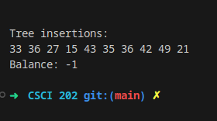
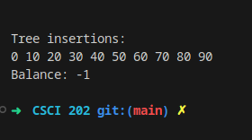

(Optional) GitHub URL

